

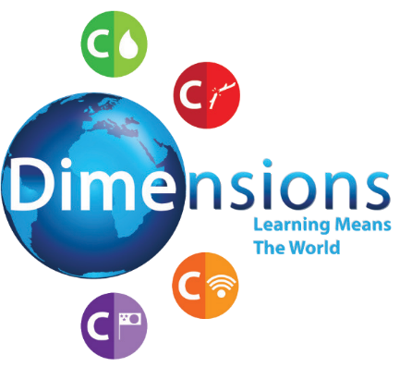

# Curriculum Newsletter

N

W E

S

Inter-Nation Media Station

**Theme Overview**

“Inter-Nation Media Station” is a thematic unit, based on media and broadcasting, with a key focus on history, through which pupils will learn about early methods of communication, leading to the invention of both the television and radio. Pupils will develop confidence in oracy, through opportunities to work on their own broadcasts.

**Maths**

In Maths we will be looking at place value and addition and subtraction.

**PSHE**

Fact and Opinion Debating

E-Safety

**Computing**

Multimedia Broadcasts

**Music**

Radio Jingles

© Dimensions Curriculum Ltd.

Wish you’d... talk confidently





# Curriculum Newsletter

N

W E

S

Inter-Nation Media Station

**Art**

Mixed Media - Colour Pops

**Drama**

Role Play - TV Studio

In Literacy we will be recapping SPaG from the previous year to make sure this is embedded aswell as learning poetry and looking at non-fiction texts.

**Literacy**

© Dimensions Curriculum Ltd.

Wish you’d... talk confidently